**Project Development Phase Model Performance Test**

|  |  |
| --- | --- |
| Date | 16 November 2022 |
| Team ID | PNT2022TMID51233 |
| Project Name | Project - Fertilizers Recommendation System for Disease Prediction |
| Maximum Marks | 10 Marks |

**Model Performance Testing:**

Project team shall fill the following information in model performance testing template.

|  |  |  |  |
| --- | --- | --- | --- |
| **S.No.** | **Parameter** | **Values** | **Screenshot** |
| 1. | Model Summary | Total params: 5,084,552  Trainable params: 5,084,552  Non-trainable params: 0 |  |
| 2. | Accuracy | Training Accuracy – 94.55 Validation Accuracy – 91.22 |  |

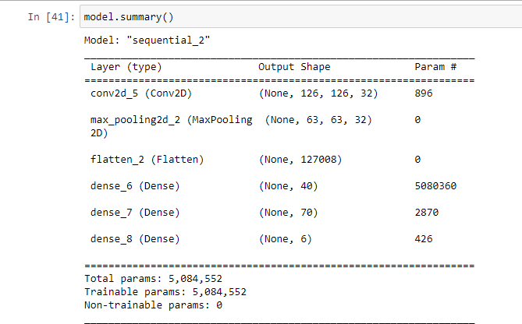**Model Summary**

**Accuracy**

